COM535 Cyber Security Lab

Instructions

- Login to https://www.hacksplaining.com/lessons

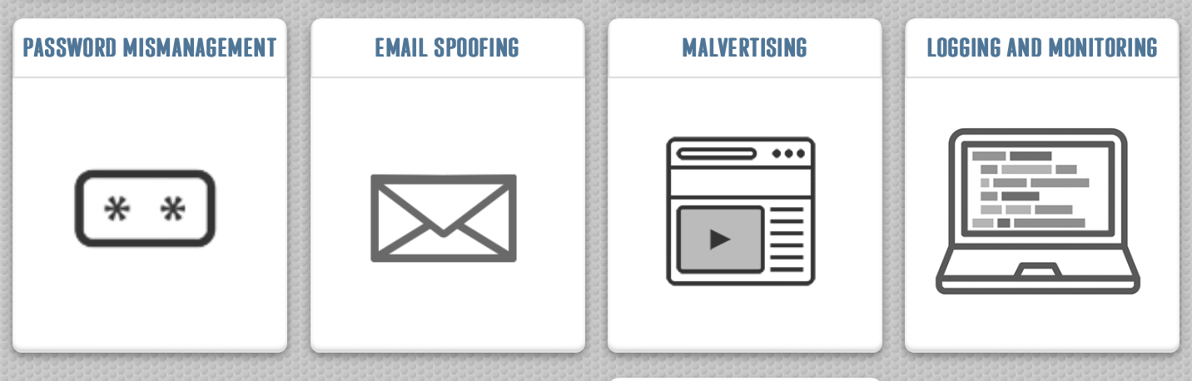

- Complete the four vulnerability lessons which are Password Mismanagement, Email Spoofing, Malvertising and Logging and Monitoring.

- Visit https://tryhackme.com/

Cyber Defence Frameworks

- Complete Junior Security Analyst Intro https://tryhackme.com/room/jrsecanalystintrouxo

Help video: https://youtu.be/9oOQLED6mRU

- Complete Pyramid of Pain https://tryhackme.com/room/pyramidofpainax

Help video: https://youtu.be/S7AxXavRNQE

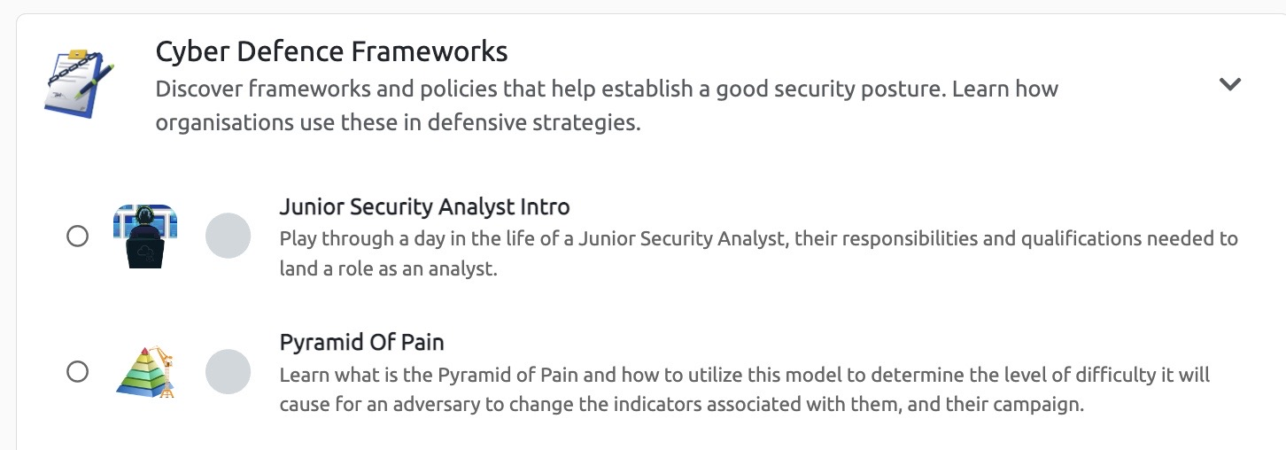

Cyber Threat Intelligence

- Complete Intro to Cyber Threat Intelligence https://tryhackme.com/jr/cyberthreatintel

Help video: https://youtu.be/OZ80zXwTh0g

- Complete Threat Intelligence Tools https://tryhackme.com/room/threatinteltools

Help video: https://youtu.be/F68zMPAdz-8

